
Parish of Newton Abbot and Ogwell
WEEKLY NEWS
24th May 2026 Pentecost
In this edition:
- Message from the Rector – the first of a series of articles on the Parable of the Sower
- Times of our Parish Prayer Gatherings for the next few weeks
- Details of our Pentecost Prayer Walk on this coming Saturday (23rd May.)
- Lunch with God returns with A Summer of Invitation!
- Blog post of the week: really helpful ideas to share our faith
- Correction to the bible readings for this Sunday
- Updated Prayer list
- Swifts and wildlife monitoring at St Bartholomew’s Church
- Seated exercise classes

FROM OUR RECTOR

Dear Friends

At the APCM last week I spoke about our desire to embed a missional DNA in our churches. That is, to make sure that we are actively obeying Jesus’ command for his disciples then and now to “go and make disciples of all nations, baptizing them in the name of the Father and of the Son and of the Holy Spirit, and teaching them to obey everything I have commanded you.” Matthew 28:19-20.
Jesus speaks about this process in the Parable of the Sower. (If you haven’t read it lately, you can find it in Mark 4, Matthew 13 and Luke 8). Over the course of the year, I’ll reflect on different aspects of the parable, starting in this column here with the simple fact that the sower needed to go out into the fields to sow the seeds.
I remember someone once commenting that churches that only proclaim Jesus within the walls of the church are like fishermen who spend their days fishing in lakes with no fish, whilst always hoping that one might have jumped in from the streams and rivers nearby.
Of course, sometimes people do walk into our churches off the street without having had a direct personal invitation. Something (The Holy Spirit!) prompts them to come, so they do. Perhaps that’s the story of how you came to Christ. You felt a pull in your spirit, came to church and heard the gospel and the rest, as they say, is history. But sadly, it’s also true that there will some people who have been in church most Sundays for most of their lives who don’t yet know Jesus or His Father. The religious leaders of Jesus’ day fit that description. They knew all the theology, all of the Bible references, all of the laws- and they did a good job keeping them; but they didn’t know Jesus and so were cut off from God’s love and grace. That’s why there is always some value in directing parts of sermons to those who are not yet Christians, because we don’t know where people sit n relation to Jesus.
But that’s a very limited view of Jesus’ command to proclaim the gospel and make disciples. In Matthew 28 Jesus commands his disciples to go out and tell people of him, in the same way that the sower in the parable goes out into his field to sow the seed.
The good news of Jesus is meant to be shared and spread, not kept to ourselves. Our witness to Jesus in our words must not just be in church or amongst Christians. (although it would strengthen our faith and witness if more of our conversations in church were about Christ!) No, if we want to play our part in fulfilling the Great Commission, we need to go out to where people are. To our schools, clubs, shops and offices. To golf courses, gyms, dog-walking lanes and coffee shops. Wherever we encounter people who do not yet truly know Jesus, those are the places we need to go with the good news of the Kingdom of God.
So, where do you spend your time? Which people do you meet most frequently? Ask yourself which of them do not yet know and follow Jesus and start to pray for ways to share something of your faith and hope with them. There’s some good advice on how to do that in the Blog of the Week later in this newsletter. Do take a read of it!
In the meantime, why not write down the names of 5 people you see regularly who you’d love to see come to a saving faith in Jesus. Put their names in your Bible and pray for them daily. Then look for opportunities to say something about your hope in Jesus to them.
Outside the walls of our churches. With people who do not yet know Jesus. That’s where we need to be speaking of him. And may God, the Lord of the Harvest, bless our efforts as we do.

Grace and peace,

Dave

Please pray for:
Our Church, our parish, benefice and diocese, our Rector Dave Brown, Team Vicars Gareth Regan and Fr. Matthew Cashmore, Curate Jon Bealey, and all others who carry out their own form of ministry.
Our King, His Majesty King Charles III, members of the Royal Family and our government.

The Episcopal Church in the Philippines

Residents in the following streets: Cricketfield Road, Croft Road, Daggers Copse, Dandelion Place, Decoy Road, Decoy Road, Florence Place, Deer Park Road Dell Court, Denbury Road.

The sick and suffering in our parish.
GIVE THANKS for the safe arrival if Anna Mirembe Muluuta - daughter to our mission partners Rachael and Bernie. Please continue to pray for Rachael as she recovers and for all of them as they adjust to a very new way of life!

The families and friends of the recently deceased.
Please let us know about anyone needing our prayers.
_______________________________________________________________________

Readings for 24th May
Acts chapter 2, verses 1 to 21
John chapter 7, verses 37 to 39 (corrected from previous information)
______________________________________________________________________

Parish Prayer Gatherings
No prayer gathering on 25th May – bank holiday

Our next morning Parish Prayer Gathering will be on Monday 1st June at St Paul’s Church starting at 9:15 a.m. Do come and join us.

Our next evening Parish Prayer Gathering will be on Monday 8th June at St Paul’s Church starting at 7 p.m.
_______________________________________________________________________

Pentecost Prayer Walk - Saturday 23rd May.
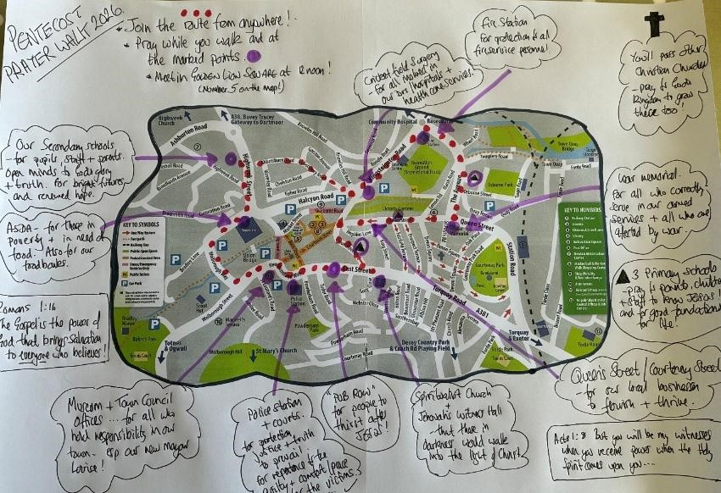
Please come and join us as we pray for God to pour out His Holy Spirit across our town. You can join in the event in 3 ways- starting at point 1 or point 2 or point 3 below! Why not get a few friends together from your church, work out the best time to start the walk and join in. (My guess is that an hour for the town centre part of the walk will be about right but take as long as you need!) Suggested gathering times for each church:
St Pauls: 10:30 a.m.
St Bart’s: 10 a.m.
St Mary’s: 10:30 a.m.
All Saints: 10:15 a.m.
Abbotsbury: 10:30 a.m.
1: Start at the church where you usually worship and pray for growth in numbers, love, maturity + mission. Then walk to the town centre and…
2: Join the pre-planned circular route, pausing to pray at some or all of the places listed on the map and (silently as you walk) pray for all those you meet on the way. 3: Be in Golden Lion Square at 12 noon to pray and sing together. We aim to finish by 1 p.m.

Maps for the town centre route will be available from the Parish Office during the week and from St Paul’s on Saturday morning from 10:45 to 11 a.m.


Lunch With God Returns with a Summer of Invitation!
Starting this Wednesday lunchtime from 12:15 to 1:45, and then every Wednesday until the end of September, Lunch with God is moving back out into Golden Lion Square.
Over that 90 minutes there will be a short talk (repeated 3 times), an invitation to ask questions about Jesus and the Christian faith and lots of freebies (Bibles, booklets, tracts) to give away.
Our focus will be on the invitations Jesus gives to come to him and all that He offers. So please can you pray for the team: for boldness and clarity and for wisdom in the talks and questions, for grace and kindness in our conversations, and for God to use this witness to bring people to himself.
And please would you come at least once over the summer. A crowd draws a crowd, so having people listen is a great help. And who knows, just being there might help equip you to share your faith with others.
_______________________________________________________________________

Fifth Sunday of May. As usual when there is a 5th Sunday in the month, we hold combined services for the whole Parish. On 31st May we will have the joint morning service at Abbotsbury Church at 10:30 a.m.
Also on 31st May, we will be joining forces with Milber Parish for Evensong at 5 p.m. at St Luke’s Church.
_______________________________________________________________________

Blogpost of the Week 10ofthose, the Christian publishing company we buy many of our books through (and for whom there is a link on the RESOURCES section of our website – see here Books, Apps and Courses - Newton Abbot Parish) also have a blog.
This week the topic is Sharing the Gospel One Conversation at a Time. With great ideas on listening first and what questions to ask, and a remind that this is ultimately God’s work, I found it really helpful. I think you might too: You can find it here: Sharing the Gospel One Conversation at a Time | 10ofThose UK

Swifts – birds of summer
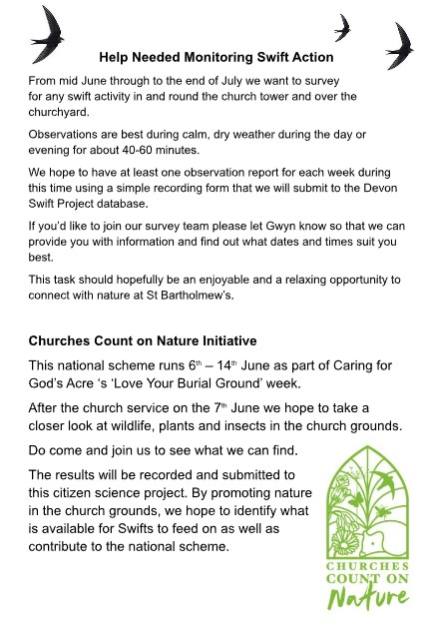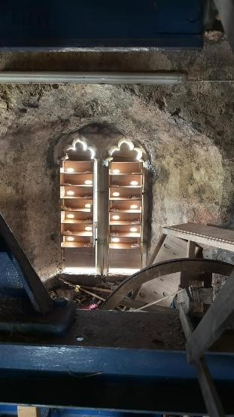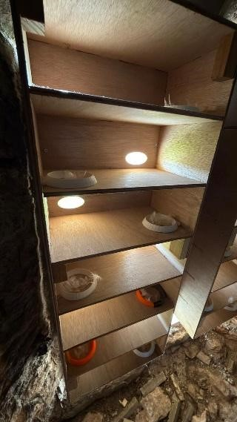

At St Bartholomew
’
s Church, efforts are being made to encourage
swifts by installing nesting spaces in the bell tower
. These are
shown in the photographs. Help is required to mon
i
tor swifts
around

the church,
an
d to record other wildlife
as explained below.

_______________________________________________________________________
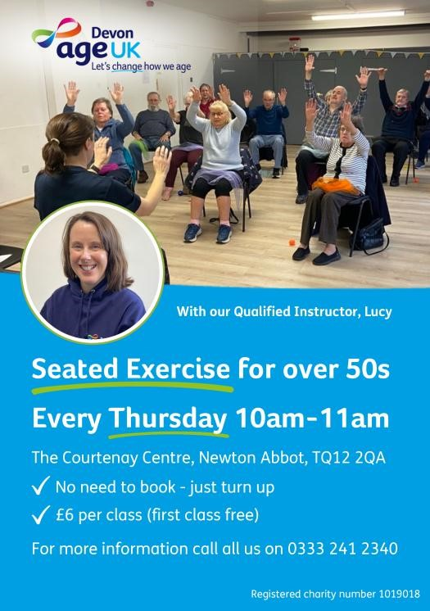
Seated exercise class held weekly at The Courtenay Centre, Newton Abbot TQ12 2QA.

A class suitable for all abilities – that is fun, gentle, and inclusive to help improve your health, strength, mobility and flexibility.

First class is FREE then £6.00 per week; this includes the class plus refreshments afterwards where we socialise and chat with the lovely, friendly group.

No need to book, just turn up or contact Age UK Devon on 0333 241 2340 for more information.

_______________________________________________________________________

COMING EVENTS
Lunch with God. Wednesdays at Golden Lion Square. 12:15 to 1:45 p.m. Bible teaching.
Pentecostal Prayer Walk. 23rd May. See details on page 3.
Charity Coffee Mornings. 30th May from 10 a.m. in the Hall at St Paul’s Church in aid of Alzheimer’s Research, and 29th May at St Bartholomew’s Church.
Craft Club. 2nd and 16th June at 2 p.m. at St Paul’s Church.
Wildlife monitoring at St Bartholomew’s Church on 7th June at 11 a.m.
Women’s Breakfast. Saturday, 13th June at 9:30 a.m. at Leisure Lounge Café.
Men’s Breakfast. Saturday 20th June, 9:00 a.m. at the Leisure Lounge Café.
Parochial Church Council. 24th June at 7 p.m. at Abbotsbury Church.
Youth Group for ages 11 to 17 at The Avenue Church on 26th June, 7.30 to 9 p.m. No meeting in May.
Charity Coffee Morning. 27th June from 10 a.m. in the Hall at St Paul’s Church in aid of Alzheimer’s Research.

CHURCH SERVICES

24th May
Abbotsbury Church, Service of the Word at 9:30 a.m.
All Saints’ Church, Holy Communion at 9:30 a.m.
St Paul’s Church, Holy Communion at 11 a.m.
St Luke’s Church, Mass at 11:15 a.m.

31st May
Abbotsbury Church, Holy Communion at 10:30 a.m.
St Luke’s Church, Mass at 11:15 a.m.
St Luke’s Church, Evensong at 5 p.m.

7th June
Abbotsbury Church, Holy Communion at 9:30 a.m.
St Bartholemew’s Church, Holy Communion at 9:30 a.m.
St Mary’s Church, Wolborough, Matins (BCP) at 11 a.m.
St Paul’s Church, Service of the Word, at 11 a.m. St Luke’s Church, Mass at 11:15 a.m.
EVERY WEDNESDAY 10 a.m. Holy Communion at St Paul's Church, Devon Square and 10 a.m. Said Mass at St Luke’s Church, Milber.
ALL WEEK St Bartholomew's Church in Ogwell is normally open for private prayer during daylight hours.
______________________________________________________________________

FUNERALS AND INTERMENTS

David (Sandy) Vaughan Edwards. Memorial Service. 12th June. 12:30 p.m. at St Mary’s Church, Wolborough

PARISH CONTACTS
Team Rector: Rev Dave Brown. Day off Thursday rector@newtonabbotparishes.co.uk 01626 335862
Team Vicar and Vicar of St Luke's, Milber: Fr. Matthew Cashmore. Day off Monday father@slsj.co.uk 07555 924862
Team Vicar: Rev Gareth Regan: Day Off: Friday.
gareth@newtonabbotparishes.co.uk 01626 201237
Curate: Rev Jonathan Bealey curate@newtonabbotparishes.co.uk 07886567732 Licensed Lay Minister: Keith Butler: puffin@blueyonder.co.uk 07980 457919
Churchwardens:
All Saints': Paul Cannock
Abbotsbury: Pauline Giddings
St Mary’s Sharon Lawrence salawrence21@outlook.com 07794 108166
St. Paul’s Lorna Tresidder lornatresidder@icloud.com
St Bartholomew's Stella Llewellyn stellallewellyn@icloud.com 01626 906814 and Gwyn Hughes. gwynhughes@icloud.com 01626 365028

Anna Chaplain: Kim Martin annachaplain@newtonabbotparishes.co.uk
Organist: Steve Cox 079 686 21511 or 01626 854228 stephen.cox54@talktalk.net
Parochial Church Council Secretary: Karen Hooker.
pccsecretary@newtonabbotparishes.co.uk 07999 891029
Safeguarding Lead: Rob Palmer 07792 081776 treb0r@hotmail.com
Weekly Parish News by Email. John Calderwood. news@newtonabbotparishes.co.uk
07760 226488
Other Communications Media (website and social media) comms@newtonabbotparishes.co.uk
IT Support it_support@newtonabbotparishes.co.uk
Prayer List. Please let us know about anyone in need of prayers. Their name will be kept on the list for a month. Please email prayer@newtonabbotparishes.co.uk
Parish website: www.newtonabbotparishes.co.uk
Parish Office at St Paul's Church, Devon Square.
The office is normally open Monday to Thursday, 10:30 a.m. to 1:30 p.m. Phone 01626 211346 or email office@newtonabbotparishes.co.uk

OTHER USEFUL CONTACTS
Newton Abbot Town Council. 01626 201120 www.newtonabbot-tc.gov.uk
Shopmobility, Ring & Ride, Community cars – 01626 335775
Teignbridge Council – 01626 361101, www.teignbridge.gov.uk
THAT Foodbank. 8 Queensway House, Queensway, Newton Abbot. TQ12 4BA. Tel:
01626 437310, email: office@thatfoodbank.com Website: www.thatfoodbank.com

Footnote. Thank you very much to those of you who have sent me contributions for our weekly news. Relevant photos are very welcome.

I aim to circulate each weekly issue on Wednesday to give notice of the coming weekend's events and perhaps report what happened last weekend.

Please let me have any news of past events, notice of future activities or any other information that may be interesting or useful for our Church members, by Tuesday for the next day’s issue.

If you know of anyone who does not receive this weekly email, but wishes to do so, please ask them to email me. John Calderwood news@newtonbbotparishes.co.uk

